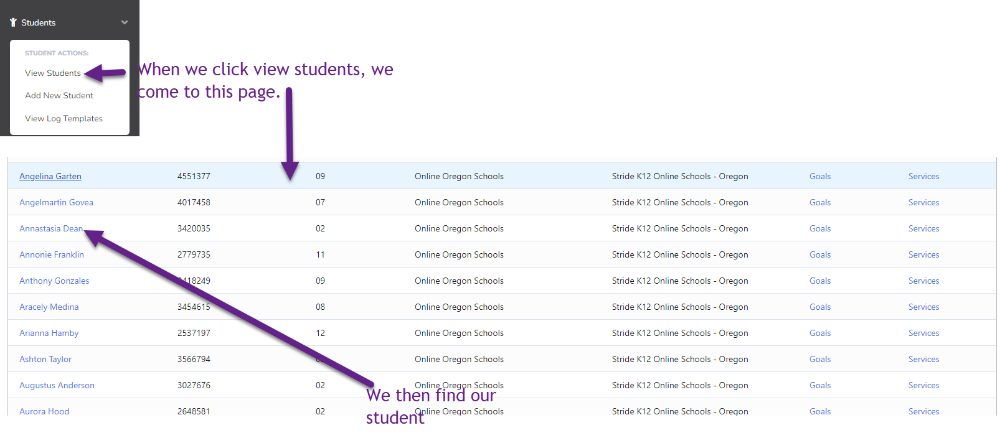
We then are taking to this page:
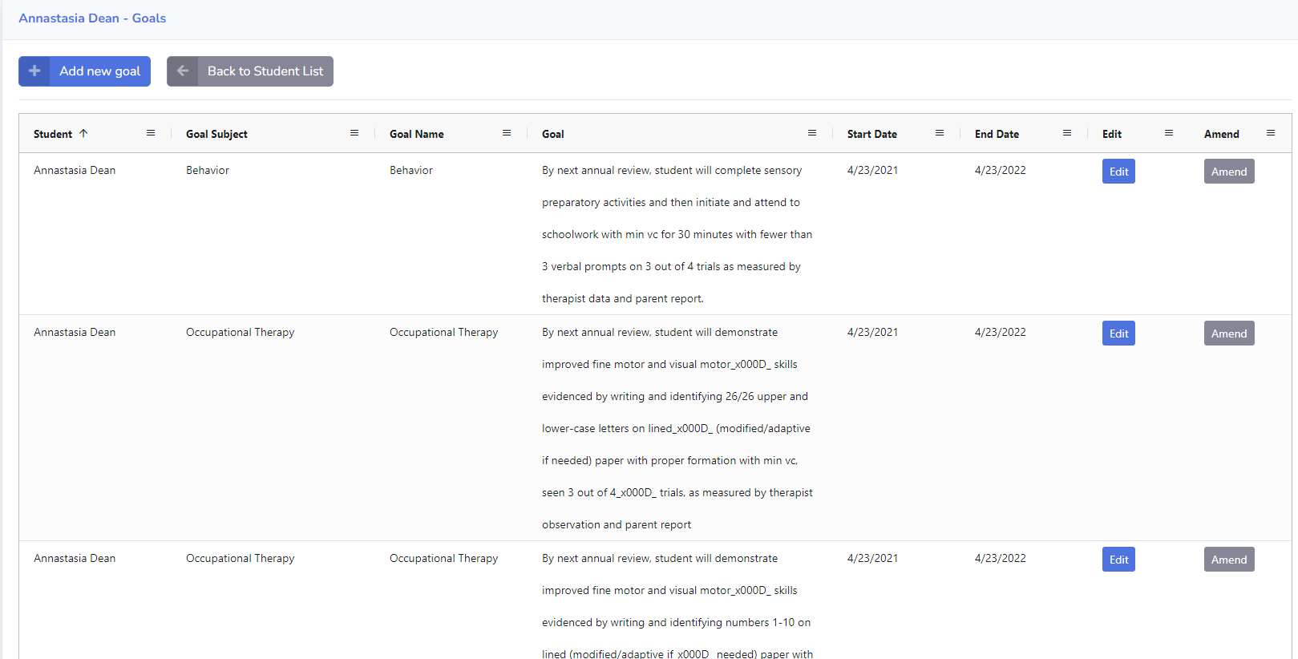

We then click on the goal we want to amend or edit
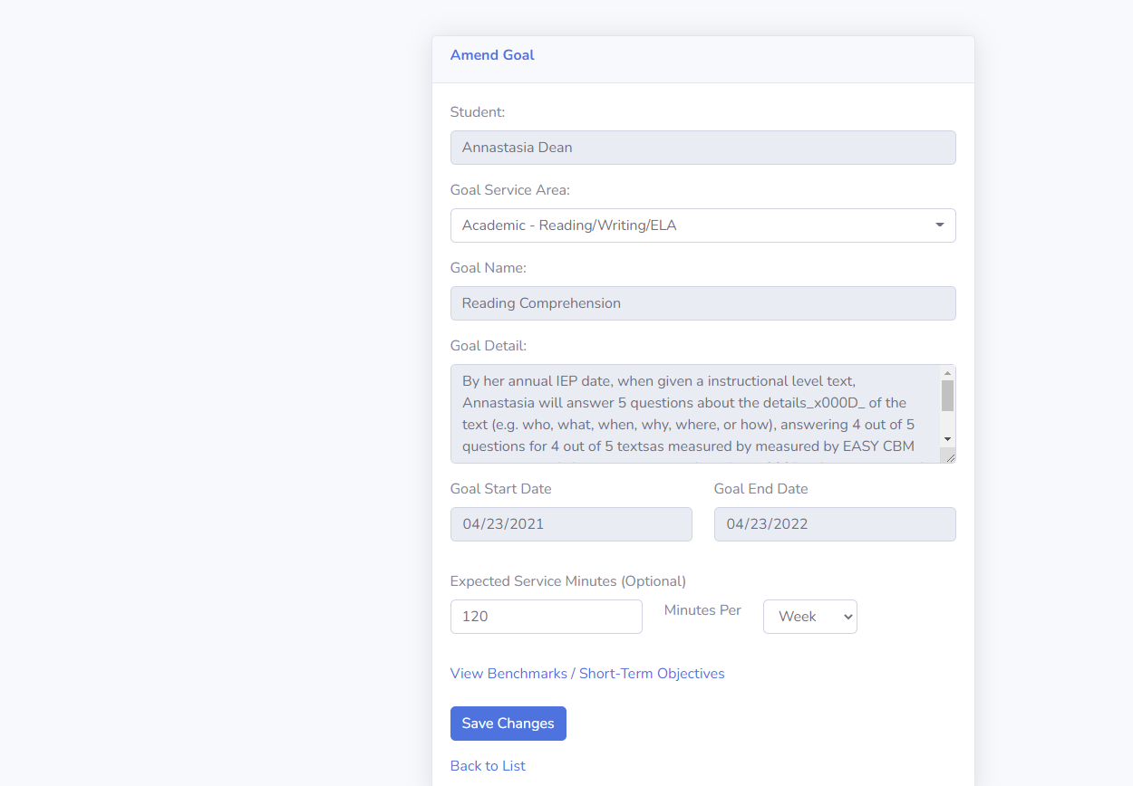 We then click save changes-put in the reason for it. But when that is complete, it takes us to this page
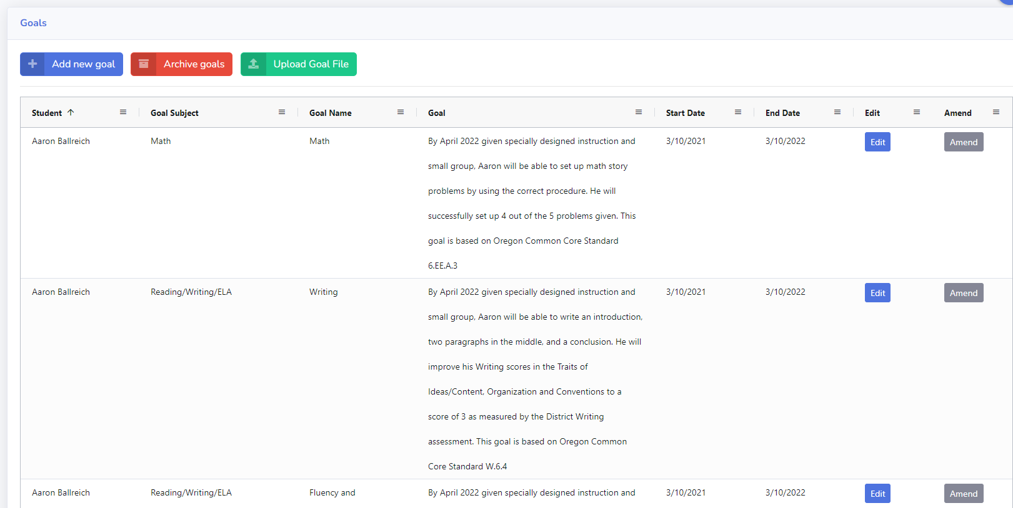
Instead of this back to this page

This page is the one that would be helpful to go back too. Not the main document area with all the students.

I hope this makes sense.

